Part 2. Machine Learning

Annie Place

2301241

1. Introduction
The aims of this investigation look to improve security aspects of the institution through the addition of a Machine Learning Algorithm within a detection system currently in use. For these purposes, a variety of different machine learning algorithms will be examined, identifying proper use for specific algorithms at hand, before identifying two different algorithms that best suit the purposes of this investigation. The algorithms will be examined under the guise of datasets provided by Nour Moustafa and Jill Slay, whom have provided these datasets graciously (Moustafa and Slay, 2015).
The dataset provided contains various packet information from a network analysis. Through the excel document of these packets, the information provided of these packets included useful datapoints such as duration, protocol, port number, and most importantly attack category. Below is a list of all the types of attacks identified within the dataset, the testers identified ten unique attack types within the dataset:
- Analysis
- Backdoors
- Denial of Service
- Exploits
- Fuzzers
- Generic
- Normal
- Reconnaissance
- Shellcode
- Worms
This paper aims to provide a proper guide and outline the steps for implementing the machine learning algorithm onto the dataset. This outline will include each step of the data pipeline, ensuring that the model is properly implemented through this process. After this guide has been laid out, there will be a couple evaluation metrics conducted on the set. These provide the ability to quantify several unique qualities of a dataset through several unique models showcasing the accuracy of these machine learning algorithms upon a dataset.

2. Background
2.1 Intrusion Detection System
An Intrusion Detection System is a security tool designed for various security functions upon a network or a host. This detection system, as the name implies, are developed primarily for the purposes of detecting malicious access points upon a network or conversely malicious log ins of a host upon a network. These tools are primarily developed for the purposes of digital forensic analysis upon a system, and thus are used during this process frequently.
As identified previously there are two distinct iterations of an Intrusion Detection System. A Host-based detection system is utilized for identifying nefarious host behaviour on a system through event logs, file alterations, as well as other behavioural identifiers. A Network-based detection system concerns the dataset focused on by this report, monitoring network traffic similar to the packets mentioned previously. This tool looks to identify nefarious behaviours through a system by identifying out of network IP addresses, unauthorized logins, and most importantly known hostile packet traffic patterns akin to attacks like denial of service.
2.2 Machine Learning Algorithms
Machine Learning is notably used interchangeably with the term ‘Artificial Intelligence’ in modern lay speak. However, as Katrina Wakefield states, machine learning is a sub-category of the greater study of artificial intelligence (Wakefield, 2019). Machine learning specifically iterates through different variations of the same problem improving based on the results of previous iterations upon the dataset. This mimicry of human learning achieves a pseudo-intelligence useful for the purposes of this study. There are four distinct types of machine learning algorithms: supervised, semi-supervised, unsupervised and reinforcement (Wakefield, 2019). Wakefield describes each category as a different means for which the algorithm iterates upon a dataset.
Supervised learning algorithms are ‘taught’ through iterative example. In other words, the algorithm is inputted with a known dataset of inputs and outputs, the algorithm then provides a method that deterministically arrives at the same conclusions as the dataset provided the input (Wakefield, 2019). When using this method of learning, an algorithm iteratively learns to predict the target variable given the features and modifiers for the proper response in order to ‘learn’ from the training dataset(Ali, 2022).
Unsupervised learning algorithms conversely learn without a clear output presented. The purpose of an unsupervised learning algorithm is to determine behavioural consistencies rather than true, rigorous outputs akin to supervised learning (Wakefield, 2019). A combination of these two, where the learning algorithm is presented some outputs and has to interpret others, would be considered a semi-supervised approach.
Reinforcement algorithms differ from the other three quite drastically, granting the algorithm defined rules and parameters rather than inputs and outputs (Wakefield, 2019). These rules give context to the purpose of the algorithm, allowing it to ‘evolve’ within its parameters to reach an end goal. Reinforcement algorithms teach the algorithm through trial and error, learning from the past experiences and adapting to the situation (Wakefield, 2019).
The next section of this report will discuss two differing algorithms of different types. These algorithms will be compared and contrasted between one another to properly identify the best approach on the given dataset.

3. ML Algorithms
3.1 K Nearest Neighbours
K Nearest Neighbours is a type of supervised machine learning algorithm generally utilized for classification purposes (GeeksforGeeks, 2017). This algorithm iterates through datasets by finding the closest datapoints to a determined value ‘k’ based off a specific input. The algorithm will then determine a prediction based on the majority class of the classification framework at hand.
K Nearest never assumes anything about the data distribution under the hood, rather it determines characteristic tendencies from the data distribution. Below are figures that illustrate the behaviours of k nearest, showcasing categorical definition developing based on a ‘k’ value predetermined by the developer.
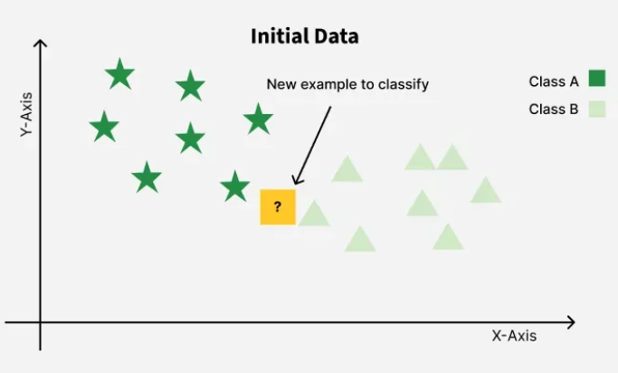
Figure 1. Graph showcasing a new ‘k’ value implemented into a dataset (GeeksforGeeks, 2017).
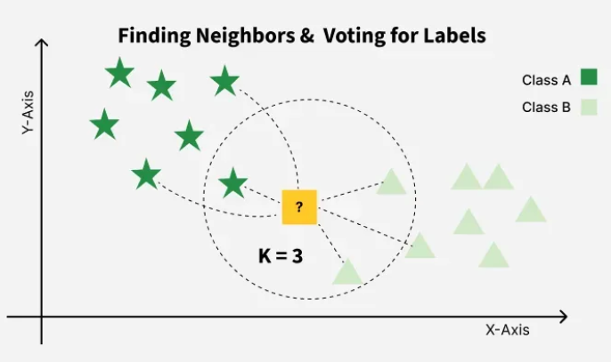
Figure 2. Graph illustrating the creation of a new category in the dataset based on the added ‘k” variable (GeeksforGeeks, 2017).
In general, streaming services such as Spotify and Netflix will utilize Nearest Neighbours as a means of recommending content to users (Elastic Platform Team, 2024). Categories are created by the algorithm to ensure that like artists or shows are recommended by the streaming habits of their userbase.
The positives of this algorithm come to fruition in use cases such as the Intrusive Detection System laid out previously. Predetermining malicious actors via a categorization algorithms based of network traffic behaviours proves fruitful in this reports use case. Once the true Nearest Neighbour in a dataset is determined, malicious network traffic can be identified and dealt with accordingly. However, within large datasets which network traffic oftentimes becomes, determining the true Nearest Neighbour proves timely. Thus, K-Nearest Neighbour allows for the forensic analysis to determine within reasonable assurance the malicious actors within the network.
However, due to the approximate nature of the algorithm, k-Nearest Neighbour will never be 100% accurate in its assessments. The downsides of this approach result in the best case false flagging of benign network traffic and at worst a lack of detection of true malicious traffic. This leads the researchers to examine another algorithm that might better suit the accuracy needs of the project at hand. Lastly, the runtime of this algorithm is quite slow, relying on a quadratic runtime, however in practice this is much faster due to the ‘k’ value.
3.2 K Means Clustering
K-Means Clustering algorithms are an unsupervised machine learning algorithm which utilizes clustering to determine groups on an unlabelled dataset (Peich, 2013). Due to the unsupervised nature of K Clustering, the groups will be determined through a pivot, or centroid that is determined through the algorithm below:
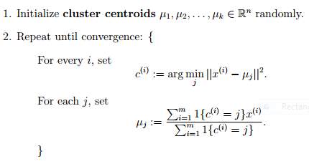
Figure 3. The K-Means Clustering Algorithm (Priet, 2013).
K-Means as an algorithm is heavily inspired by another known algorithm, Expectation Maximization, where in which the algorithm iterates with hidden variables upon a dataset in an attempt to determine the maximum likelihood of set parameters (Priet, 2013). This better defines K Clustering as a classification algorithm in machine learning, utilizing its identification properties on a randomized dataset.
K Clustering algorithms are immensely popular for how quickly one can implement a simple script of the algorithm onto a dataset. The widespread nature of K-Means Clustering comes in part to its versatility in a variety of datasets. Acting as the “jack of all trades master of none” machine learning algorithm of sorts, K Clustering is a relatively quick learning algorithm, running at a linear speed in computer time (Google, 2024).
However, for a K Clustering algorithm to be useful, the developer must preset a ‘k’ value the algorithm can iterate upon. This algorithm proves useless in problems where an initial variable cannot be determined, leading to a bottleneck (Google, 2024). On top of this, due to the behaviour of the runtime of the algorithm relying heavily on 3 linear variables, the addition of several dimensions results in a multiplicative increase in runtime.
3.3 Determination
For the purposes of this dataset, K Nearest Neighbours is most suitable for the Intrusion Detection System. Given enough time on a dataset, Nearest Neighbours allows for the implementation of true Nearest Neighbours, which can result in perfect network analysis. However, even given a limited time to analyse a dataset, k-Nearest Neighbours would develop false positives that a developer can identify and eliminate from the dataset. K Clustering relies to heavily on a small number of dimensions, and with 10 different identifiers the runtime alongside the same limiter of accuracy as Nearest Neighbours provides no benefits to Clustering over its counterpart.

4. Implementation
Nearest Neighbours implementation of the dataset requires several steps. These steps will be outlined below with details relating to the dataset provided.
Firstly, a the vertices must be initialized as unvisited. For this context, these vertices will be the packets sent upon the dataset.
These vertices will then be selected at random, where once visited the identifier of the packet will be identified, where the identifier is the attack vector: normal, fuzzers, denial of service, etc.
From this the “closest edge” connecting the packet to its closest neighbour will be identified, connecting the vertex “u” to the now known vertex “v”. The v variable will be reassigned to the new u vertex as the now visited v vertex will be labelled as visited.
Once all vertices, in this case packets, are visited and identified, the algorithm will terminate with every identifier determined. This report will now determine different evaluation metrics to ensure effective implementation of the machine learning algorithm at hand.

5. Evaluation Metrics
Evaluation Metrics are a means in which to evaluate the effectiveness of a machine learning algorithm upon a dataset. The metrics for the purposes of the k Nearest Neighbours algorithm will be a precision model as well as a Confusion Matrix.
The precision model determines the accuracy of a model within the evaluation metric. This is calculated via the ratio of True Positives to the number of Predicted Positives. Positives, in this context refer to the amount of harmful packets upon a network identified vs the amount expected under normal circumstances. Below is the Formula for this precision model:
Precision = TP / (TP + FP)
Conversely, a Confusion Matrix is a methodology that visualizes the performance of the algorithm upon the dataset. The matrix consists of four possible outcomes: True Positives, False Positives, True Negatives, and False Negatives. Due to the accuracy of the Nearest Neighbour algorithm, there should never be an idealized Matrix, however there should be an acceptable amount of False Positives within implementation. Below is the Matrix containing the four variables at hand:
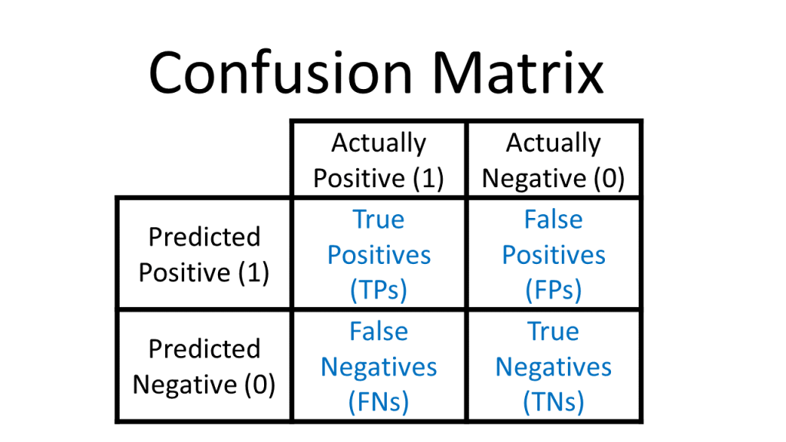
Figure 4. An image of a Confusion Matrix (Draelos, 2019).

References
Moustafa, Nour, and Jill Slay. "UNSW-NB15: a comprehensive data set for network intrusion detection systems (UNSW-NB15 network data set)." Military Communications and Information Systems Conference (MilCIS), 2015. IEEE, 2015.
Moustafa, Nour, and Jill Slay. "The evaluation of Network Anomaly Detection Systems: Statistical analysis of the UNSW-NB15 dataset and the comparison with the KDD99 dataset." Information Security Journal: A Global Perspective (2016): 1-14.
Moustafa, Nour, et al. "Novel geometric area analysis technique for anomaly detection using trapezoidal area estimation on large-scale networks." IEEE Transactions on Big Data (2017).
Moustafa, Nour, et al. "Big data analytics for intrusion detection system: statistical decision-making using finite dirichlet mixture models." Data Analytics and Decision Support for Cybersecurity. Springer, Cham, 2017. 127-156.
Sarhan, Mohanad, Siamak Layeghy, Nour Moustafa, and Marius Portmann. NetFlow Datasets for Machine Learning-Based Network Intrusion Detection Systems. In Big Data Technologies and Applications: 10th EAI International Conference, BDTA 2020, and 13th EAI International Conference on Wireless Internet, WiCON 2020, Virtual Event, December 11, 2020, Proceedings (p. 117). Springer Nature.
Wakefield, K. (2019) A guide to machine learning algorithms and their applications, SAS. Available at: https://www.sas.com/en_gb/insights/articles/analytics/machine-learning-algorithms.html. (Date Accessed: January 26, 2026).
Ali, M. (2022) Supervised Machine Learning, www.datacamp.com. Available at: https://www.datacamp.com/blog/supervised-machine-learning. (Date Accessed: January 26, 2026).
GeeksforGeeks (2017) KNearest Neighbor(KNN) Algorithm, GeeksforGeeks. Available at: https://www.geeksforgeeks.org/machine-learning/k-nearest-neighbours/. (Date Accessed: January 26, 2026).
Elastic Platform Team (2024) Understanding the approximate nearest neighbor (ANN) algorithm, Elastic Blog. Available at: https://www.elastic.co/blog/understanding-ann. (Date Accessed: January 26, 2026).
Piech, C. (2013) K means, Stanford.edu. Available at: https://stanford.edu/~cpiech/cs221/handouts/kmeans.html. (Date Accessed: January 26, 2026).
Google (2024) Advantages and disadvantages of k-means, Google for Developers. Available at: https://developers.google.com/machine-learning/clustering/kmeans/advantages-disadvantages. (Date Accessed: January 26, 2026).
Draelos, R. (2019) Measuring Performance: The Confusion Matrix, Glass Box. Available at: https://glassboxmedicine.com/2019/02/17/measuring-performance-the-confusion-matrix/. (Date Accessed: January 26, 2026).

